Visualizing convolution data

# Visualization of layers data

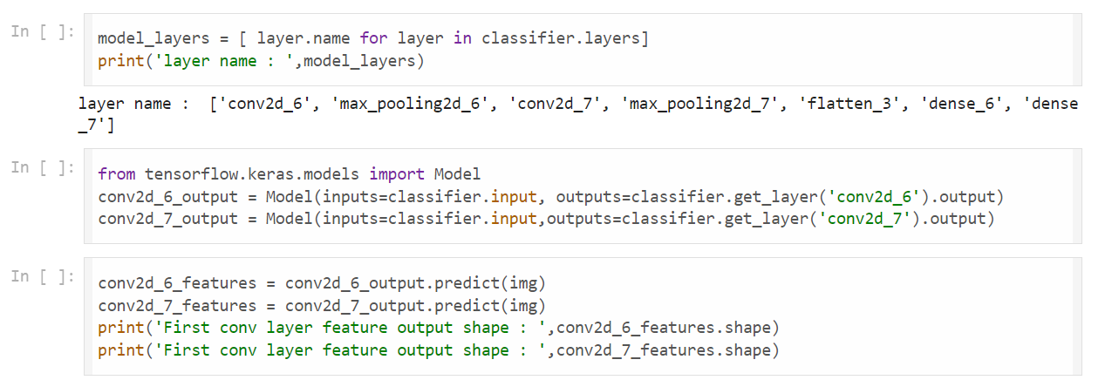

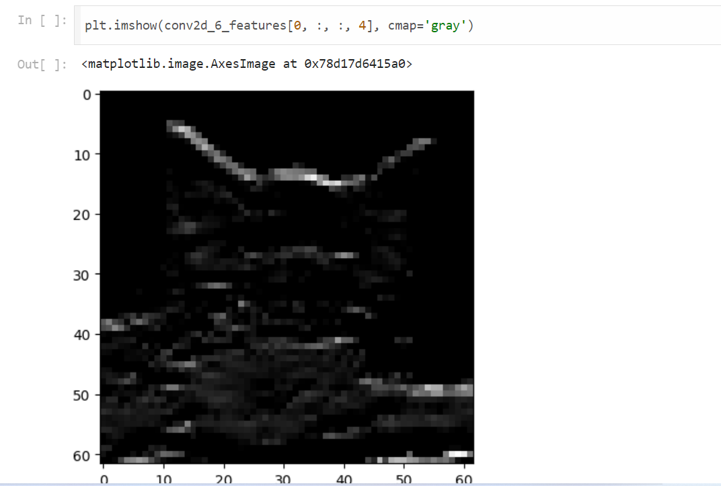

# First Covolution Layer Output

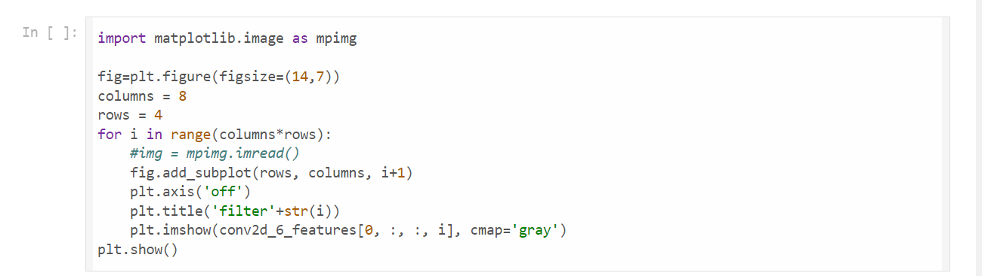

# 

# Second Covolution Layer Output

